Week 1 – Homework

#**************************

Please see the attached word document for the Question 3 graph.

#**************************

Please note all homework is due submitted on-line by 1PM CST (Dallas) on Wednesday September 6.

For now, send me an email to [cmaybin@smu.edu](mailto:cmaybin@smu.edu) titled MSDS_8310 - [Last Name] - Week 1 Homework. For example, my submission would be titled MSDS_8310 - Maybin - Week 1 Homework. In the email should be the following (2) attachments containing the answers to the questions below:

* 1 Word document: Questions 1, 2, 3, 4 part a-c
* 1 R File: Questions 4 part d

Please keep all written answers short – say no more than 4 sentences.

Question 1 – Load a word document with the following answers:

Please give working definitions of the following:

1. What is a market? A market is simply a structure, exchange, or establishment that facilitates the transfer of anything from a buyer to a seller
2. What is money? Money is a medium of exchange. This does not necessarily mean that it has any intrinsic properties which make it valuable on its own.
3. What is a firm? A firm is a group of individuals or investors who perceive an opportunity for arbitrage in the marketplace via the offering goods and services to consumers.
4. What is demand? Demand is the principle describing an individual’s desire and ability to pay for the goods or services offered by suppliers. It is essentially the amount of goods or services that consumers wish to consume at a given price all else equal.
5. What is supply? Supply is the total amount of goods or services offered to consumers are each given price point all else equal.
6. What is utility and what is it used for in economics? Utility is simply the benefit derived from consuming goods and/or services
7. What is a price? Price is the amount of money that individuals are willing to pay for a good or service
8. What does the “Law of supply and demand” mean? Given that demand represents the amount of goods desired at a given price and that supply is the amount of goods or services provided at a given price the law of supply and demand is the combination of the two. Essentially, given a price for an item, consumers will continue to demand more of an item supplied as the price declines to the point at which suppliers will no longer supply additional goods or services at the lower price. We generally think of this point as the point of equilibrium.

Question 2 – With our new expertise, please explain how the following affect the price of money?

Supply

1. What causes a shift in quantity supplied (i.e. along the curve)? Generally, we call a shift in the quantity supplied, a change in the quantity supplied. The only thing that causes movement along the curve is a change in price. In general, as the price of an item increases, produces will increase the quantity supplied
2. What causes a shift in the supply curve (i.e. moves the curve itself)? A shift of the entire supply curve is generally the result of a change in a factor that directly impacts the operation of the firm. These factors usually include costs, changes in technology, government policy, and environmental factors.

Demand

1. What causes a shift in quantity demanded (i.e. along the curve)? Movement along the demand curve is also determined by changes in price.
2. What causes a shift in the demand curve (i.e. moves the curve itself)? Shifts in demand are also caused by several factors. These factors include changes in tastes and preferences of consumer, the prices of complimentary and substitute goods, and changes in income or population.

Question 3 – Using the graph (below – or see the attached file if this is not showing up on the wall), answer the following:

1. Which curve is shifting – Supply or demand? The supply curve is shifting in this image
2. What do the points where each of these curves intersect mean? What do we call each of these points? The points where the curves are intersecting mean that the quantity demanded equals the quantity supplied. We call each of these points the point of equilibrium.

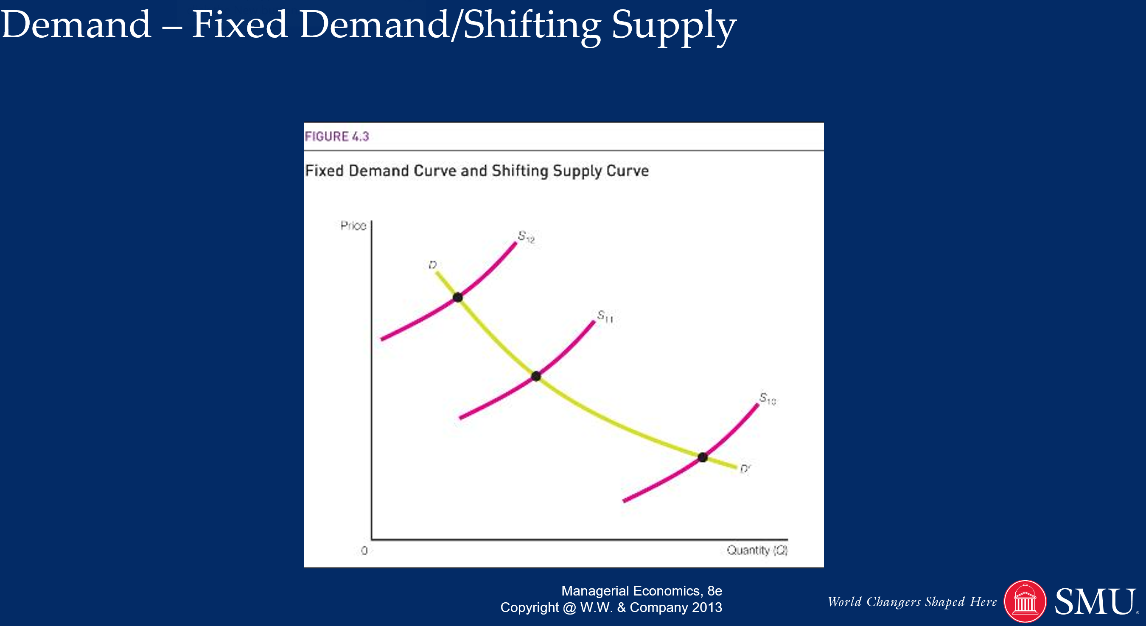

Question 4 – Practical Learning: Recursion. Run the following code and answer these questions:

1. What is the most “important” part of this code (i.e. what should you always make sure you have defined first)?
2. What line of code defines/makes this a recursive function versus any other type of function?

The line of code that makes this recursive is in the else statement of the if statement. In this statement, the function calls itself

1. What kind of mathematical function is this? This is a factorial function
2. Iterate and plot this function for x=1:10 in your R code. No need to have separate output, I will run when I review your code.

#*********

#Code adapted from www.programiz.com

#https://www.programiz.com/r-programming/recursion

#*********

my.recursive <- function(x=7) {

#terminating condition

if (x==0) return (1)

#recursive condition

else return(x * my.recursive(x-1))

}

my.recursive(x=8)

#********************